Derivation of DL/dz

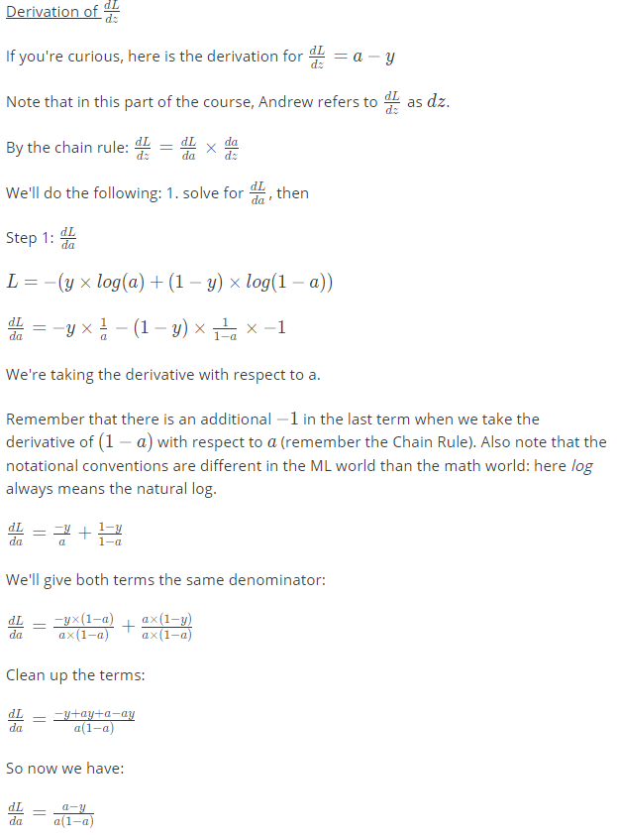

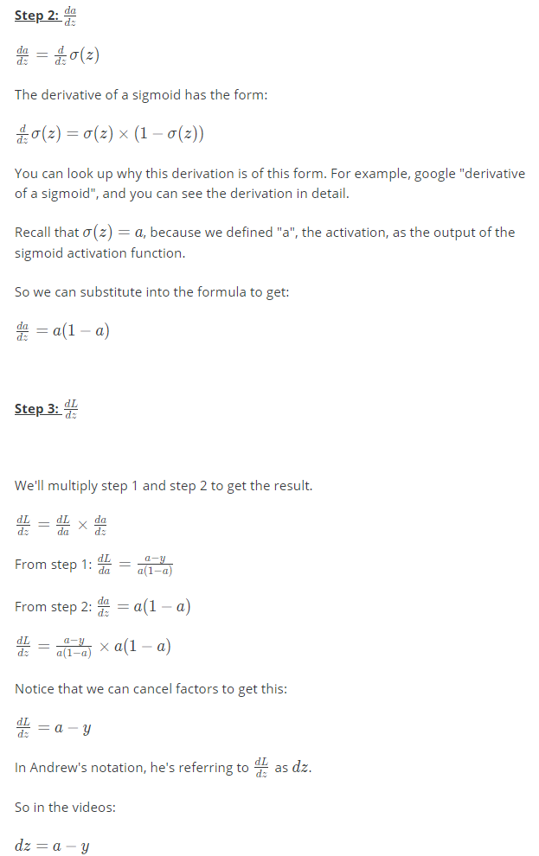

**Sigmoid Gradient**

**Where s is sigmoid**

**Sigmoid-derivative(x) =** sigmoid_derivative(x)=σ′(x)=σ(x)(1−σ(x))

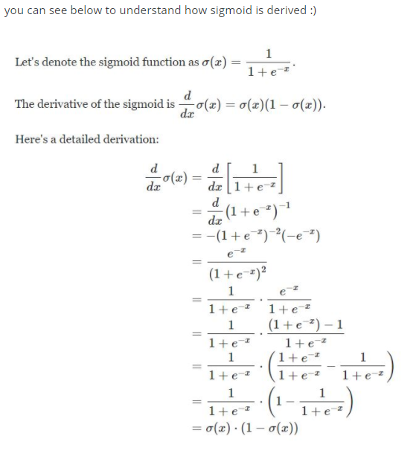

**Check these links to find out more about how derivative of sigmoid is derived/calculated:** [**https://towardsdatascience.com/derivative-of-the-sigmoid-function-536880cf918e**](https://towardsdatascience.com/derivative-of-the-sigmoid-function-536880cf918e)

[**https://kawahara.ca/how-to-compute-the-derivative-of-a-sigmoid-function-fully-worked-example/**](https://kawahara.ca/how-to-compute-the-derivative-of-a-sigmoid-function-fully-worked-example/)